

Instruction Manual

Table of Contents

What is Marimba? 3

Why Marimba? 3

Installing Marimba 4

Requirements 4

Installation 4

Upgrading 4

Running Marimba for the First Time 5

Logging In 5

Main Menu 6

About 7

Recent Activity 7

History 7

Change Password 7

Merge Files 7

Save and Save As 8

Mail Menu 8

Membership Menu 9

Sign-in 9

Sign Up 10

Attendance 11

Profile 12

Unsubscribe 13

Export List 13

Fees 13

Digital Receipts 14

Financial Menu 15

Budget 15

Fees 16

Add Items 16

Export 17

Term Summary 17

Election Menu 18

Starting an Election 19

Exporting Elector List 19

Other Election Features 19

Making Marimba Better 19

Special Thanks 20

# What is Marimba?

Marimba is an information management program designed to manage and store all of the information related to the club. In addition, it helps with processing this data and finding it. Many tasks, such as recording fees and attendance, can be done directly in Marimba. Perhaps most significantly of all, Marimba handles everything.

# Why Marimba?

*Excel is pretty good isn’t it?*

Excel is pretty good, but Marimba is highly specialized software designed to handle the complex nature of the club. Excel can handle individual instances of the club well, but not the whole. For example, Excel can handle recording the membership fees paid for a term, but can that tell us who owes membership fees? What about if that member owes fees from a *past* term? Is that member eligible to vote in an upcoming election? Also, how much of the membership fee revenue has been spent? Excel doesn’t answer these question easily.

Marimba on the other hand does, because Marimba *thinks* about the club the way the club actually functions. It thinks about a member as a member joining in terms. It realizes members owe membership fees. It knows those membership fees turn into our revenue.

This isn’t to say Excel will no longer be used. In fact, Marimba exports and imports a lot of data from Excel. The reason is Excel is great for data analysis, displaying data, and sorting data. Marimba handles the basic and routine cases, but Excel is need for more complex analysis. For example, Marimba can display a term’s attendance. However, suppose you wanted to know what the average number of terms a member in a term had been part of the club. Marimba can provide the data to answer this question, but Excel would be needed to conduct the analysis.

# Installing Marimba

Marimba needs to be installed to:

* Put Quicksand Book and Quicksand Bold on your computer
* Associate .mrb files (Marimba files) with Marimba
* Give .mrb files a special icon

## Requirements

Marimba requires the following:

* A Windows Operating System (at least XP)
* .NET Framework 4.0 (if you don’t know what this is, don’t worry about it; you will be prompted to download it upon installation if it is not on your computer)
* A bunch of other trivial requirements you most certainly satisfy, like having ~35 MB of free space

## Installation

Navigate to the setup.exe file (as of this writing, located in UWCBC/Marimba). Run the file. You will need to be an administrator on your computer to install the file. Follow the on-screen instructions.

## Upgrading

Occasionally, Marimba receives an upgrading. To upgrade, run the new installation file. It will handle your upgrade. **It is very important to upgrade when upgrades are made.** Upgrades usually affect the .mrb file, and you often cannot open new .mrb files with old versions of Marimba.

# Running Marimba for the First Time

There are two ways to start Marimba: run Marimba from your computer or open any .mrb file.

The first time you run Marimba, you will be prompted to open an .mrb file (Figure 1). Select your .mrb file and open it. Every time you run Marimba (without opening a file) from now on, Marimba will remember the location of the last file you opened. If Marimba can’t find the last file you opened, it will give you the prompt for selecting a file to open again. Opening a file directly overrides this feature.

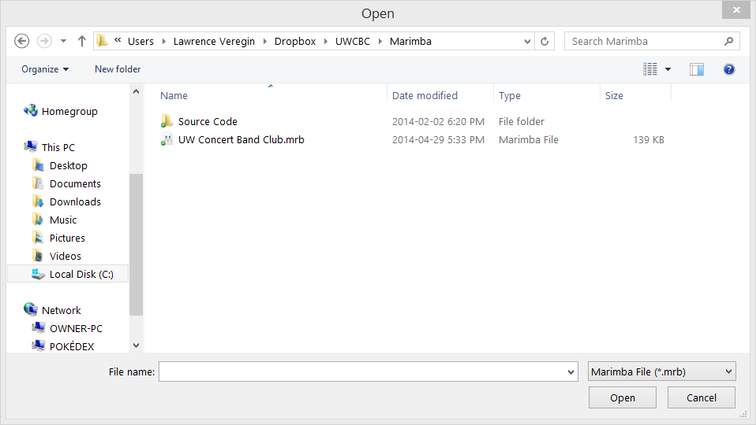

Figure 1 - Open an .mrb file.

# Logging In

To help protect the sensitive data Marimba keeps and track changes, Marimba requires you to log in (Figure 2). Access to Marimba is by invitation only. A user account must be created for you. You will be given the user ID and initial password. Your user ID cannot be changed, but you may change your password in Marimba.

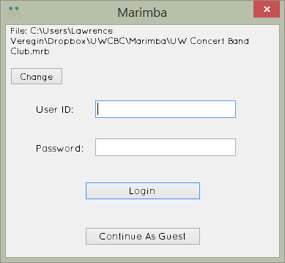There are two types of accounts: admin and exec. Admin accounts allow full control and access to Marimba data. Exec accounts have a few features that are withheld, such as the ability to create new members and new terms.

Figure 2 - Logging In.

The Continue As Guest feature is to allow signing in of members without logging in. See “Signing In” for more information.

# Main Menu

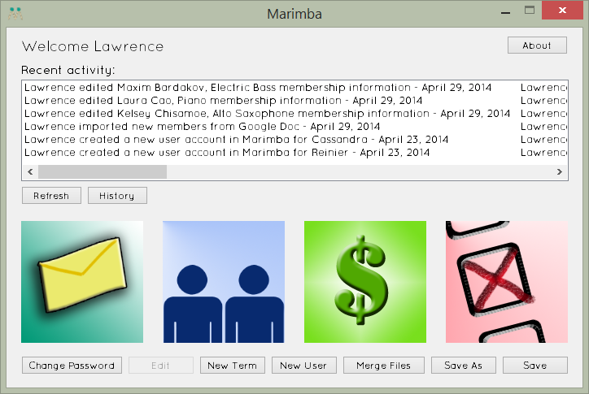

Figure 3 - Main Menu (with Admin account).

The Main Menu acts as a portal to the club’s data.

## About

The about menu features acknowledgements to key contributors of the project. In addition, it will let you know what version of Marimba you are currently using.

## Recent Activity

This lists recent additions or changes made in Marimba. Click the refresh button to refresh the recent activity list.

## History

History displays a complete list of all changes made in Marimba. The purpose of this to all any changes to be tracked and followed up on later if necessary.

## Change Password

Here you may change the password to your account. I recommend you change it from the one initially given to you. The .mrb file is not publically available (as of this writing), and as such there is no need for an exceptionally strong password. In addition, passwords are **not** stored as plaintext (i.e. unencrypted).

## Merge Files

This feature allows Marimba to take two files of the same club and combine their data into one file (Figure 4). The purpose of this is for using multiple computers to do sign-ins or take attendance. Not all types of data are merged. Financial data (including fees paid) is not merged. Please be aware of that.

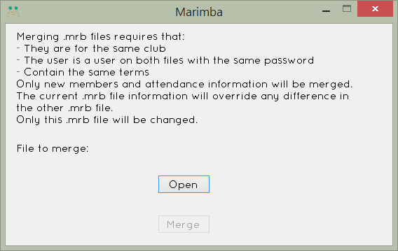

Figure 4 - Merging .mrb files.

Click the Open button and navigate to the .mrb file you want to merge into the currently opened file. Then, click merge. If there was an error, Marimba will notify you.

## Save and Save As

Changes made to Marimba are not automatically saved. Please press save to save your changes made. If you wish to save them to another location, use save as. If you close Marimba with saving your changes, Marimba will prompt you, asking if you wish to save before you quit.

# Mail Menu

The mail menu lets you send a message to an individual, all members in a term, or to the entire club mailing list. It is currently only compatible with Gmail accounts, and you will need to know the club’s email password for this account.

This mailing feature is used elsewhere in Marimba.

# Membership Menu

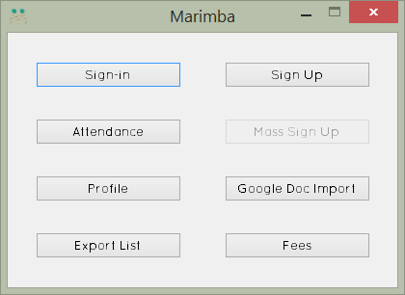

Figure 5 - Membership Menu.

The Membership Menu contains the features related to members their involvement in the club.

## Sign-in

If you run sign-in on a day that is not a rehearsal date, you will receive a prompt asking you if you wish to continue. If you attempt to record attendance, the attendance will not be saved, but any members you list will be added to the term.

If it is a rehearsal date, it will run as intended. A member can enter his or her name into the Find Member field, and Marimba will search for the member. It will look for the name a member signed up for the club under. Members can also edit their club information here if it is incorrect. Once the member has been selected, press enter or click Sign In to sign in.

The bottom area displays attendance records. Grey means a rehearsal has not occurred yet. Red means did not attend a rehearsal. Green means did attend the rehearsal.

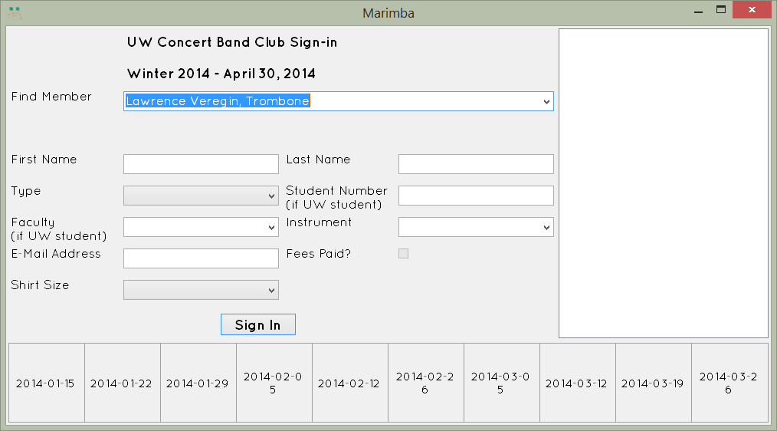

Figure 6 - Sign-in.

The white area on the right will display a list of all members signed in at the rehearsal.

## Sign Up

This displays a standard form for signing up members. This is the equivalent for adding them to our mailing list. Any member added will now appear in the list of members for signing in at a rehearsal. Marimba also checks if the member is on the mailing list already. If so, it will prevent the duplicate entry.

## Attendance

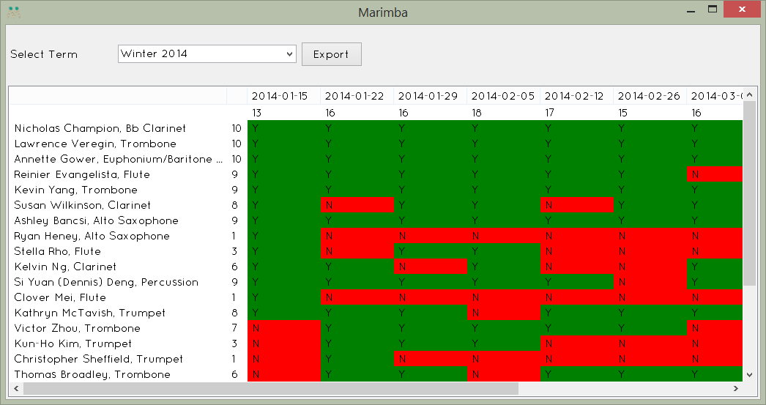

Figure 7 - Attendance of Winter 2014.

Once the attendance window is open, select a term from the dropdown menu. After a term is selected, the Export button may be clicked. This allows the attendance data for the term to be saved as an .xlsx or .csv file which can be opened in Excel.

Clicking any of the columns will sort the data alphabetically. Clicking again will sort the data in reverse alphabetical order. Double clicking a members name will open their profile (more on that under “Profile”). Clicking any individual record (a Y or N) will change that individual record to the opposite. If a member has attended 0 rehearsals, you may delete a member from the term by pressing the delete key. This does not unsubscribe, deactivate, or delete the member, but rather removes them from the term.

## Profile

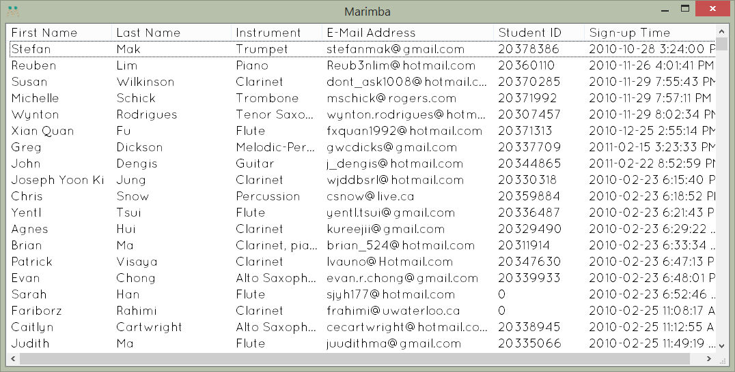

Figure 8 - Profile.

Profile displays a complete list of all members who are on the mailing list. Clicking an individual column will sort the data alphabetically. Typing a member’s first name will search for that member’s record. Double click a record to open it.

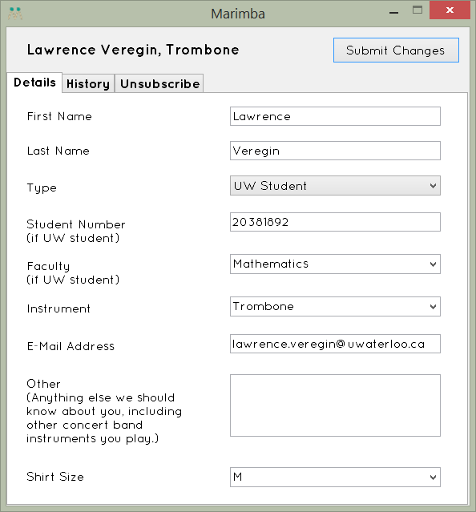Opening a profile allows you to access information in three tabs. First, there is Details. This allows editing of details such as one’s name, email address, etc.

Figure 9 - Lawrence Veregin's profile.

Second, there is history. This displays a list of all terms a member was part of the club, all fees paid, and whether or not any fees are still owing.

### Unsubscribe

To unsubscribe a member, go to the member’s profile, and click the Unsubscribe tab. There are two options, Deactivate and Unsubscribe. Only one of these buttons needs to be used to “remove” a member. It is worth noting neither of these removes a member.

Deactivate simply removes one’s email address. The purpose of this is for graduating members who do not mind the club holding on to record of their involvement of the club, but no longer have need to be on the mailing list. Unsubscribe removes all personal information from one’s profile. This includes his or her name, email address, and student number. For the purposes of keeping attendance records intact, the profile still exists, but without personal information.

If an unsubscribe request appears in the email, unless the member has made clear otherwise, one should assume they intend to unsubscribe and not deactivate. **Deactivating instead of unsubscribing when an unsubscribe request is given is a privacy violation!** The fact we could indefinitely hold on to one’s personal information without their knowledge is highly unethical.

## Export List

This allows one to export the entire mailing list as an .xlsx or .csv file. This is useful for sending emails through the Gmail account. To send an email through the Gmail account this way, open the file in Excel. Select up to 500 (a Gmail limit) email address cells from the email address column. Paste these in the BCC field of a new email in Gmail.

## Fees

A members fees can be recorded here. Select the term and the fee that is to be recorded. A list of members who have not paid this fee appears. Multiple members can be selected by holding the “Ctrl” key while clicking their names. If the amount paid is different than the actual amount that would normally be owed, change the default number. Enter the date the fees were paid. Click Add to record them.

As soon as a term is entered, the Export button may be clicked. This will save an .xlsx or .csv file of all the fees paid in a term. This is useful is one wants to print the list or quickly generate a list of who still has to pay.

### Digital Receipts

By checking Send Digital Receipt, a digital receipt will be sent to the member informing them that their fee has been recorded. If checked when Add is clicked, a pop up will appear requesting the email password be entered. **It is a known bug that if the incorrect password is entered, the fees will be recorded without sending a digital receipt.** Until this is fixed, be extra cautious to ensure the correct password is entered.

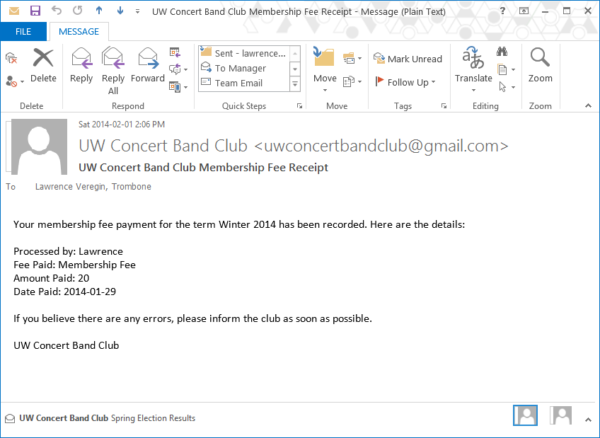

Figure 10 - Sample digital receipt.

# Financial Menu

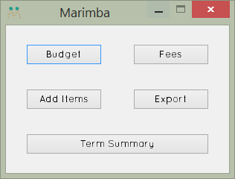

Figure 11 - Financial Menu.

The Financial Menu contains features that are useful for the VP of Finance and for obtaining information useful for purchasing decisions.

## Budget

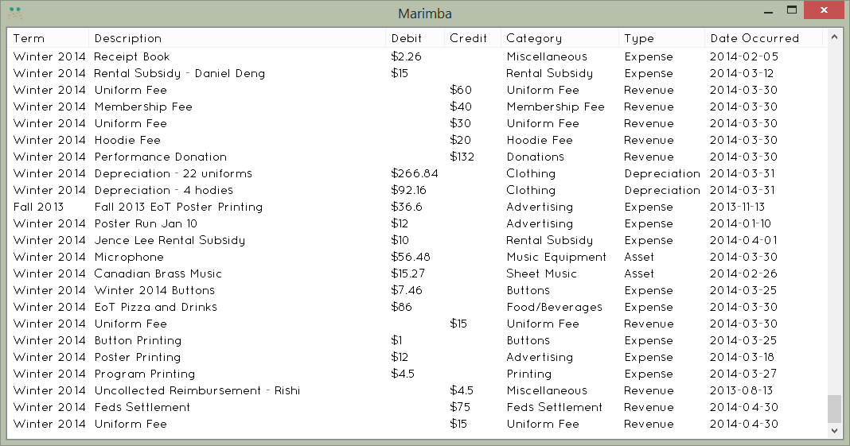

Figure 12 - Screenshot of Budget.

Budget contains a complete list of all transactions and financial events that have incurred. Clicking a column will sort the column alphabetically. Clicking again will sort the entries in reverse alphabetical order. Double clicking an entry will allow one to edit entries in the same manner in which they are entered (see Add Items for more details). Fees recorded through Fees are also shown here.

Debit items are items that reduce the club’s cash or profit. Credit items are items that increase the club’s cash or profit. Assets, depreciation, and expenses are all debit items. Revenue is a credit item.

## Fees

This is the exact same form as seen in the Membership Menu. Read the Fees section under Membership Menu for more details.

## Add Items

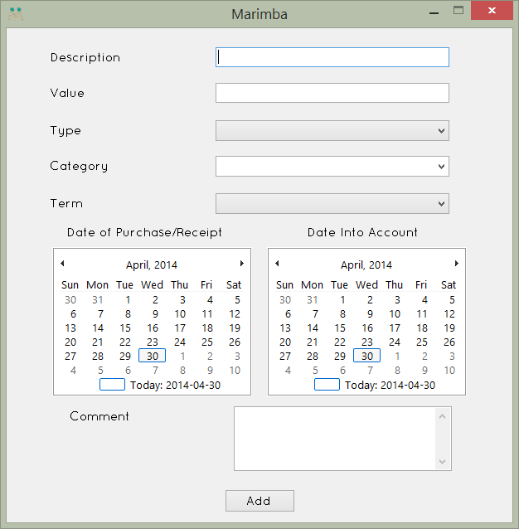

Figure 13 - Add Items form.

This form records financial transactions and events. All fees (e.g. membership fees) should not be recorded using this form, and should instead be recorded using the Fees feature. A short but useful description should be added. The value is a number (i.e. 16.57) without a dollar sign representing the magnitude of the financial transaction or event. It is important to select the correct type of transaction (asset, revenue, expense, or depreciation). Selecting the wrong types will result in incorrect financial statements. Select a category of the transaction. If no suitable category exists, you may enter a custom name. The term selected should be the term the transaction affects. This may differ from the term a transaction takes place during and the term the transaction goes into the account. If any comments are necessary to explain the unusual nature of a transaction, add them.

## Export

Export allows all financial items recorded in the budget to be exported to an .xlsx or .csv file which can be opened in Excel. This may be useful for doing audits against Feds’ account summaries. It functions exactly the same as all other export to .xlsx or .csv features.

## Term Summary

Term Summary produces financial statements for the selected term based on the fees paid and the financial transactions during the term. While in most cases they will be accurate, if complex financial arrangements occur beyond the scope of Marimba, they will not be. Also, the statements are designed to be accurate as of the end of the term. View a statement during the term will result in information being present inconsistently with standard accounting practices. As it is management accounting as opposed to financial accounting, the records follow a unique standard. They are designed to be accurate, informative, and easy to read. Clicking the Export button will save an .xlsx or .csv of the term selected and the financial statement whose tab is currently open.

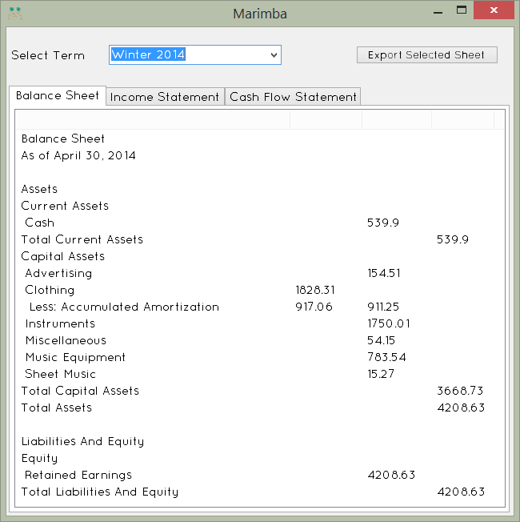

Figure 14 - Winter 2014 Balance Sheet.

# Election Menu

**Disclaimer: The Election features are not completed as of this writing.**

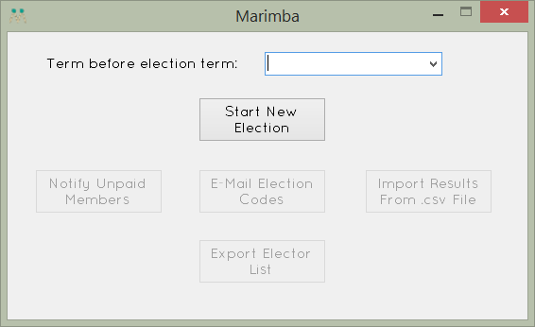

Figure 15 - Election Menu.

## Starting an Election

To start an election, select the term before the election term from the dropdown list. For example, if the election is for Spring 2014’s executive officers, select Winter 2014.

Upon creation, determines two lists. The first is a list of electors, those eligible to vote. The second is a list of members who would be electors, but due to unpaid membership fees, are ineligible until they pay. The criteria for determining who is an elector (i.e. all membership fees paid, UW student, active member in one of the past two terms) is built into the code of Marimba and cannot be changed within the program.

## Exporting Elector List

This will export an .xlsx or .csv file containing the list of eligible electors for the election and the list of members who owe membership fees before they will be able to do so.

## Other Election Features

The remaining election features are placeholders. They currently do not work. Do not use them.

# Making Marimba Better

As a Marimba user, your life has been made easy. Club data is just a click away. Return the favour by helping keep Marimba great!

* Install updates as soon as possible
* Do not let two people open the exact same Marimba file at the same time
* Keep the information confidential
* Report bugs you discover
* Make feature suggestions
* Leave comments when adding budget items when necessary
* Do not give anyone access to your Marimba account
* Add new data regularly so everyone is kept up to date with the latest club information

# Special Thanks

Kevin Chen and Krista Poon for providing the inspiration for this project.

Nicholas Champion for his ideas for how to handle attendance, membership, and terms, as well as the atomized budget.

Cathy Zhang and Cassandra Beaton for their work on presenting financial information.